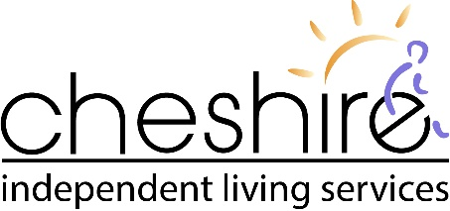

2021-2022 HEALTH & SAFETY POLICY STATEMENT & GOALS

HEALTH & SAFETY POLICY STATEMENT
The health and safety of our employees is important. Our policy is to strive for the highest possible level of safety and to comply with all applicable laws. We are committed to the prevention of occupational illness and injury. We believe that prevention is key to reducing the human and economic costs associated with workplace injuries, accidents and illness. We do this with the help and cooperation of our employees and consumers. Everyone must be conscientious about work safety including proper work methods, reporting potential hazards and decreasing known hazards.

Cheshire will make every reasonable and practical effort to provide and maintain a safe and healthy occupational environment. It must be remembered that most work areas are consumers’ private homes and as such warrant respect for individual needs, styles, cultures, likes and dislikes.

Cheshire employees, consumers, leaders and board members are responsible for complying with all legislative and organizational policies, procedures and practices related to health and safety. Moreover they are responsible for actively promoting, identifying and reporting the need for change or updating current information and practices.

While prevention is our goal, Cheshire is also committed to the active rehabilitation of workers who are injured. We do this by providing early and safe return to work duties where necessary and by working cooperatively with the injured worker and their health care providers to develop return to work strategies that facilitate their recovery.

Cheshire continues to work towards the elimination of workplace injuries. Working with our Joint Occupational Health & Safety Committees and building on the foundation of a comprehensive Health & Safety program, our goals this year will focus on the following areas:

- Immunization- Given the current state of the active global pandemic it is important from a Health & Safety and infection prevention and control perspective for Cheshire to research and adopt a stance on the promotion of immunization for staff and consumers to protect them from complications related to outbreaks associated with influenza, influenza-like illnesses (ILI), and pandemics.

- Return to Work- Cheshire will establish a well-maintained line of communication between an injured worker and management, while ensuring the roles and responsibilities for both as outlined in Cheshire’s Policies and Procedures, The Workplace Safety and Insurance Act and the Occupational Health and Safety Act are being followed by all parties. Cheshire will provide more training covering Workplace Injuries, WSIB and roles and responsibilities to all of its staff.

- Injury Reduction- Cheshire will continue to promote the reduction of workplace injuries by identifying and implementing initiatives that encompasses the current health and safety management system while expanding to include the efforts of program level joint health and safety committee members.

- Hazard Identification and Awareness- Cheshire continues to promote the reporting of all workplace hazards and will continue to establish hazard campaigns with a strong focus on Occupational Illness. Cheshire will Network with like agencies to find additional training programs that will benefit our staff, and to help to mitigate risk while ensuring a safe workplace for all.

- Psychological Health & Safety- Cheshire will continue to expand its resources for all staff in relation to mental health. Cheshire will commit to seeking opportunities for training of managers and front-line staff. Cheshire will leverage with outside resources that support front line staff.

Thank you for being our partner in Health & Safety.

